***Lab 10-ASP.NET Identity (Google & Facebook authentication)***

*Create a new MVC Application:*

*File > New > Project > Project Name: “Lab 10-ASP.NET Identity Google” > MVC > OK*

*On execution of the project following will be the output.*

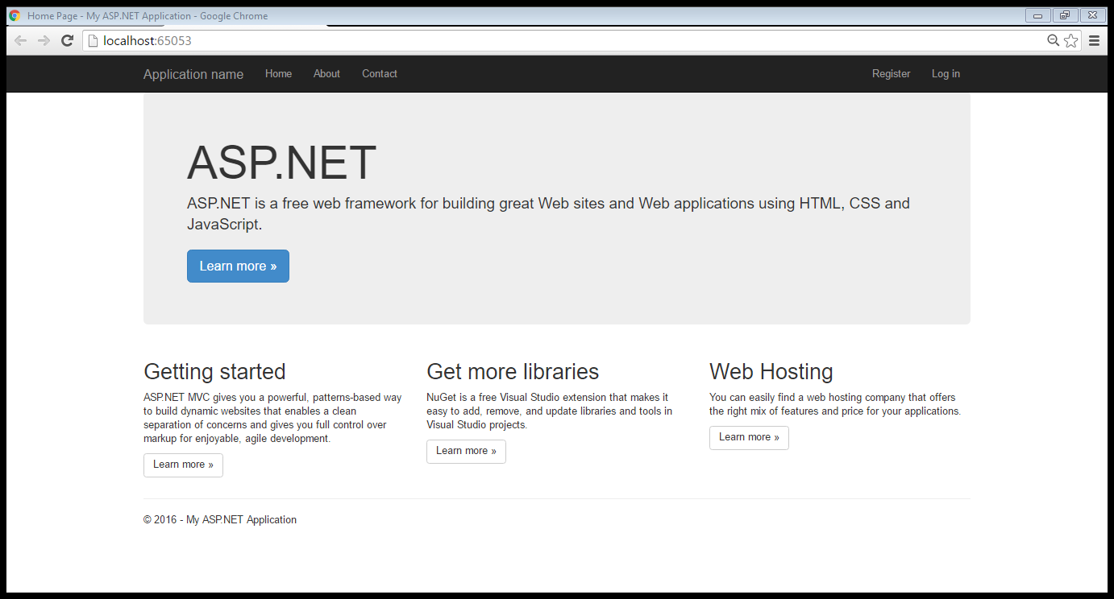

*Now click on “Log In” and following will be output:*

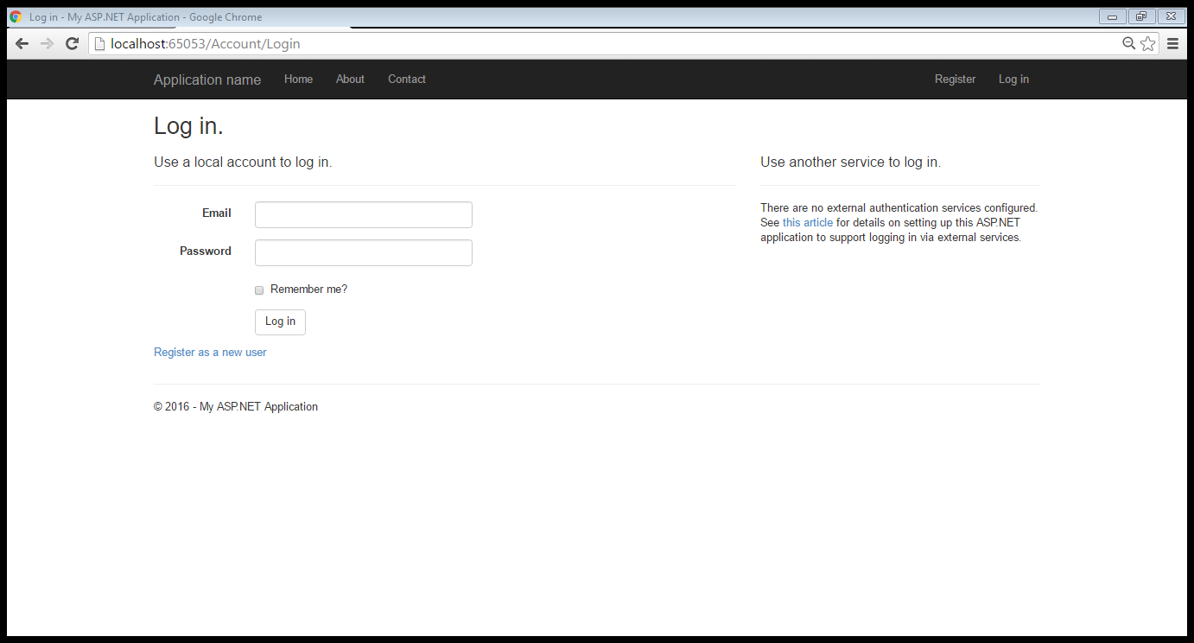

*Now we will code for “use another service to log in”. We shall use Google as third party login.*

*The necessary code shall be written in Startup.Auth.cs.*

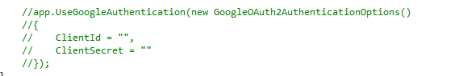

*Before we uncomment the above code, let’s see how to generate ClientId and ClientSecret. Follow the steps given below:*

* *Login in to your Gmail Account.*
* *Goto* [*https://console.developers.google.com/*](https://console.developers.google.com/) *following window will be opened*

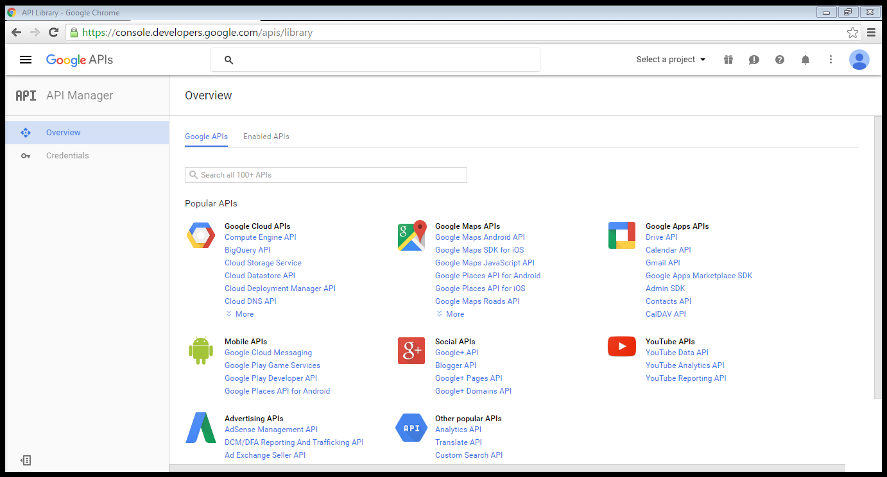

* *Now click on “Select a project” > “Create a project”*

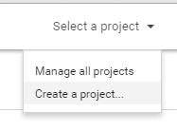

* *Change the project name: MySuperApps > Select No radio button for updates > Select Yes radio button for Terms and conditions > Click Create button*

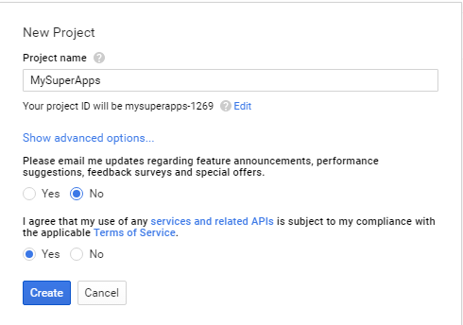

* *From the left pane of “API Manager” > Select “Overview” > Under “Social API’s” > select “Google+ API”*

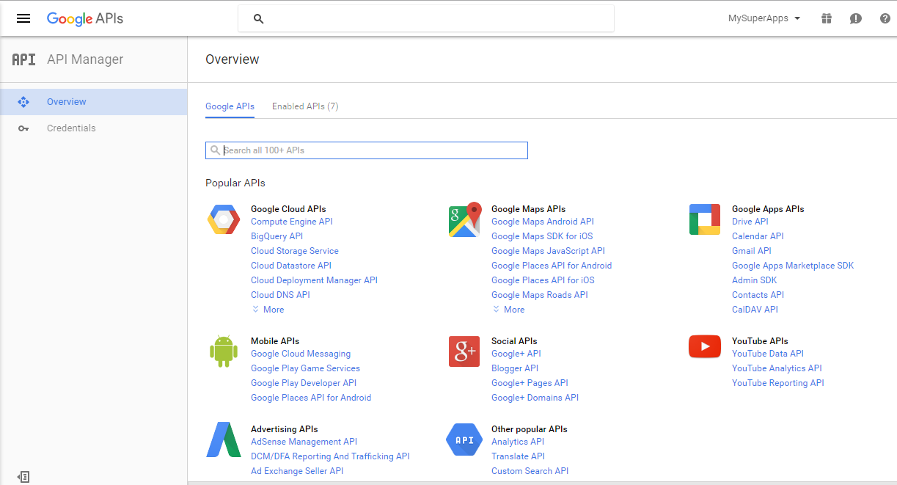

* *Click on Enable button*

*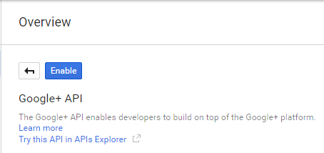 >*

*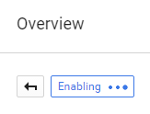 > 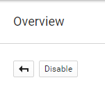*

* *From the left pane of “API Manager” > select “Credentials” > go to “OAuth consent screen” > Select your email address > Product Name : “MySuperApps” > Click on Save button*

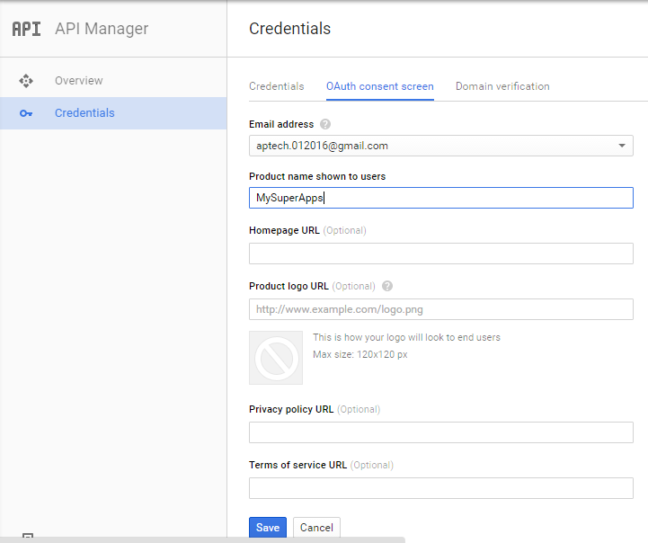

* *From the left pane of “API Manager” > select “Credentials” > click on Click on down arrow of “create credentials” button > Click on “OAuth client ID” option*

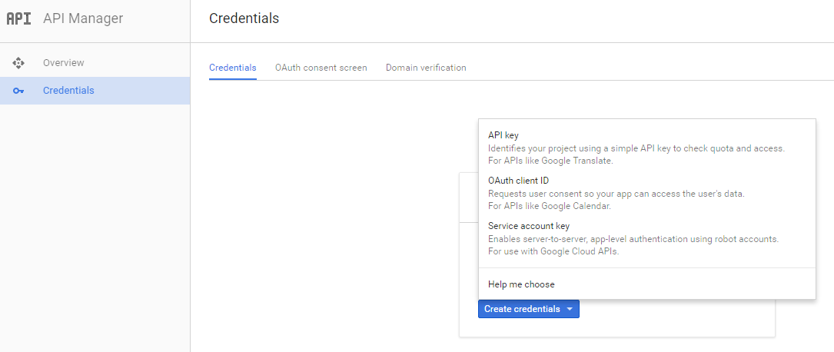

* *Execute the Project, we will require the URL of the project:*

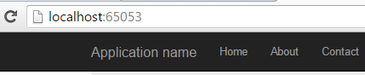

* *Select “Web Application” radio button > Enter Name: “Authentication using Google” > enter the project URL followed by sigin-google. Enter following in Authorized redirect URL : “*[*http://localhost:65053/signin-google*](http://localhost:65053/signin-google)*” > Click “create” button*

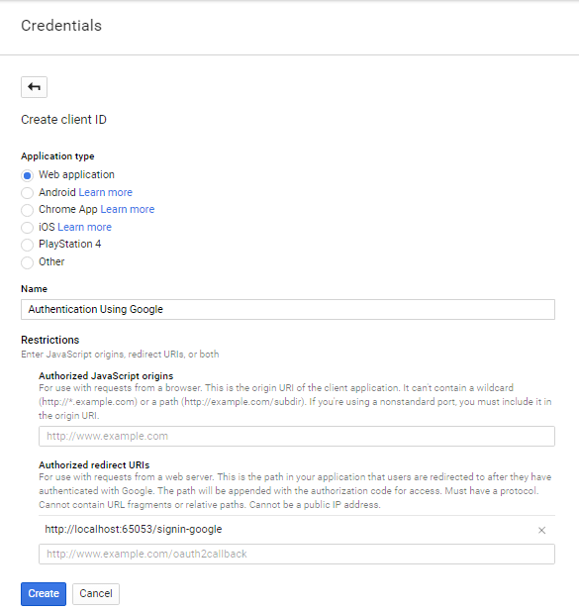

* *ClientId and ClientSecret will be generated*

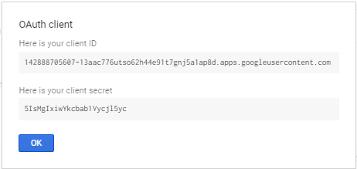

* *Enter below ClientId and ClientSecret details in Startup.Auth.cs as shown below:*

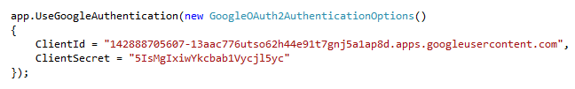

* *Logout from Gmail Account*
* *Now execute the code:*

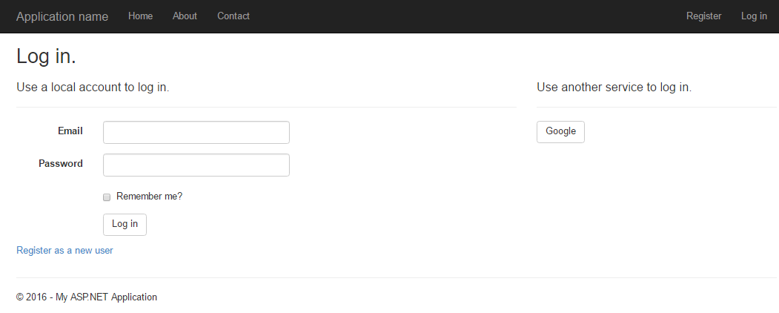

*Click on Google button*

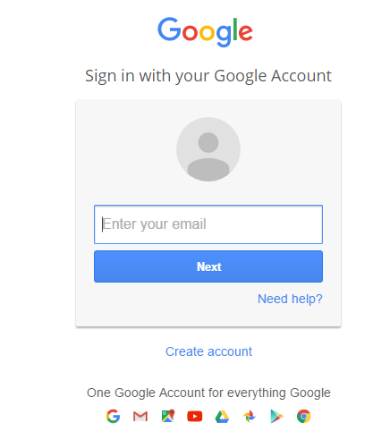

*Enter the username and password:*

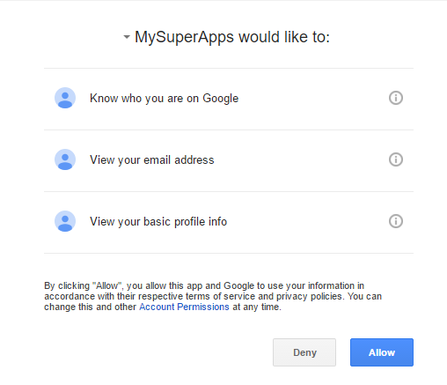

*Click on Allow button*

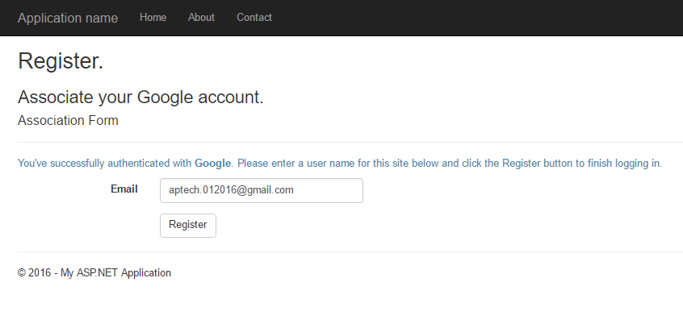

*Click on Register button*

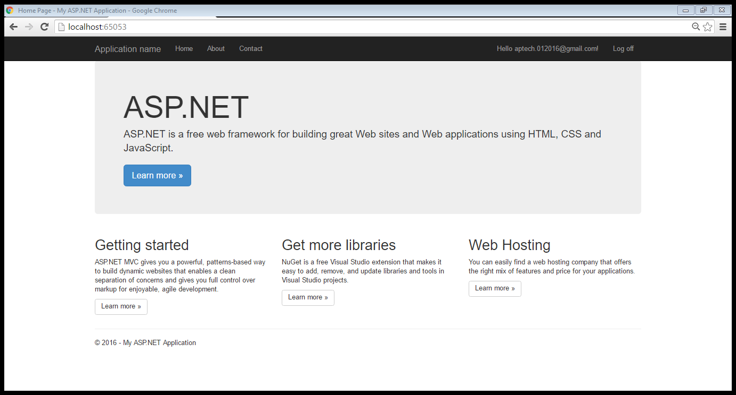

*Now we shall create the authentication using Facebook. We shall follow the steps mentioned below for generating the appId and appSecret details which need to be updated in Startup.Auth.cs:*

**

* *Go to* [*https://developers.facebook.com/*](https://developers.facebook.com/) *website > Click on Log In button and enter your facebook credentials.*

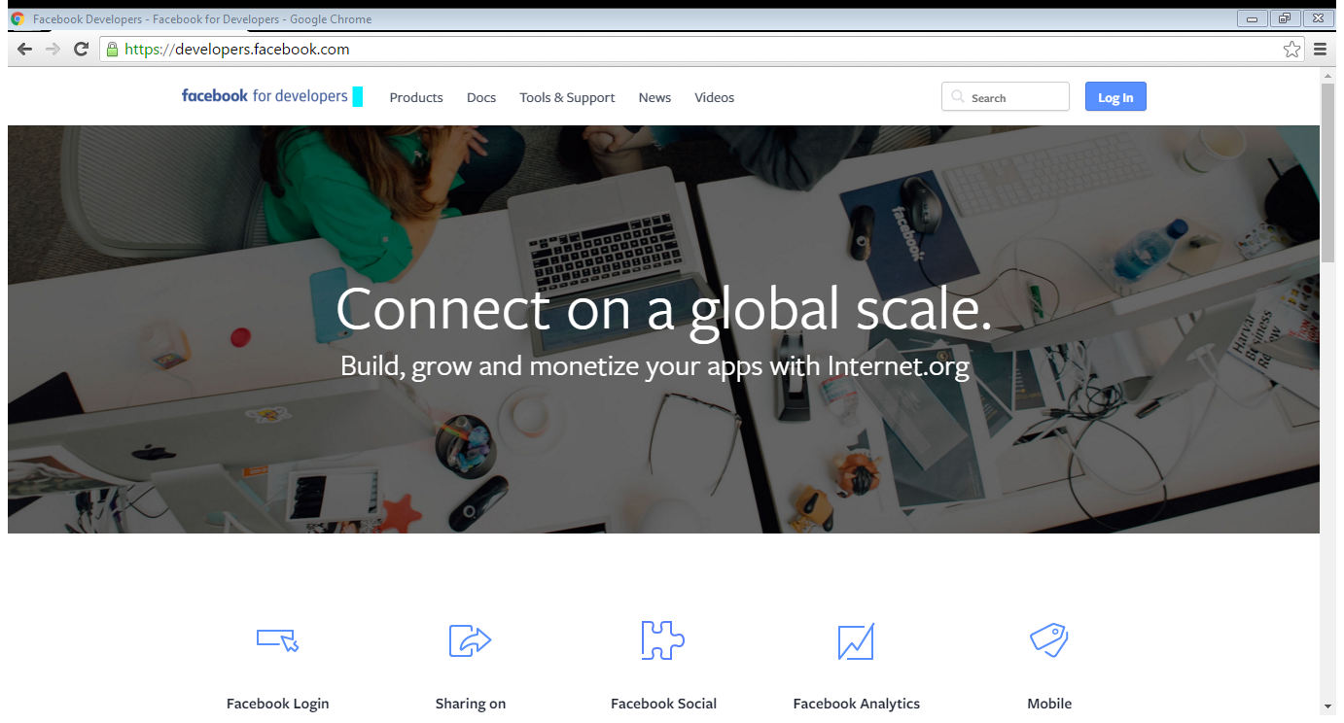

* *Now register yourself as developer by clicking on Register button*

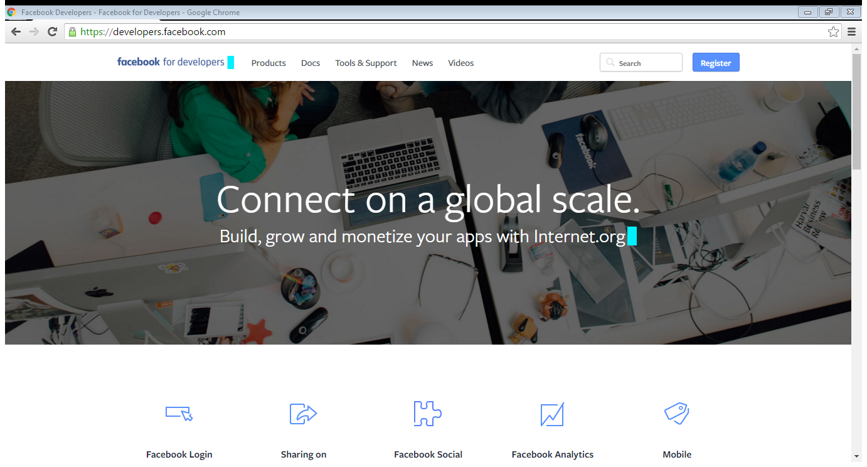

* *Select Yes for Facebook Policy > Click on Register button > After Success message is displayed click on Done button*

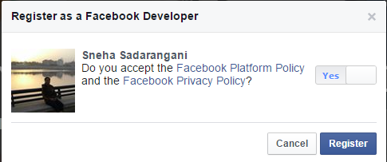

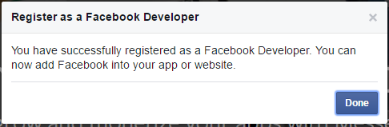

* *Now from the Add a new App window, select Website*

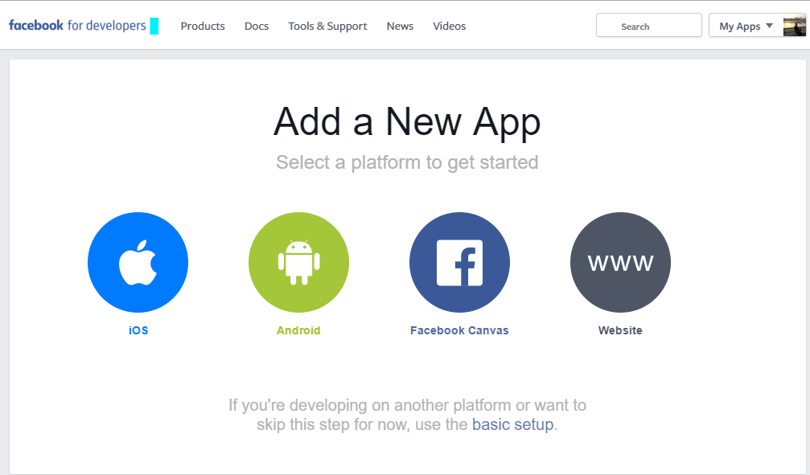

* *Click on Skip and Create App Id button*

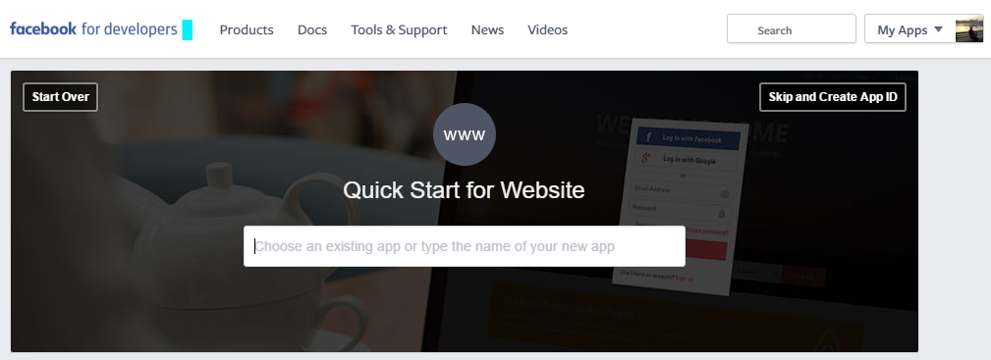

* *In the “Create a New App Id” window, Enter Display name : “MySuperApp” > Select category : Education > click on “Create AppId” button*

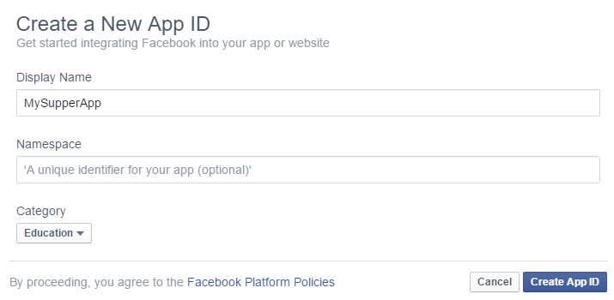

* *Perform the security check, follow the steps mentioned and click submit.*

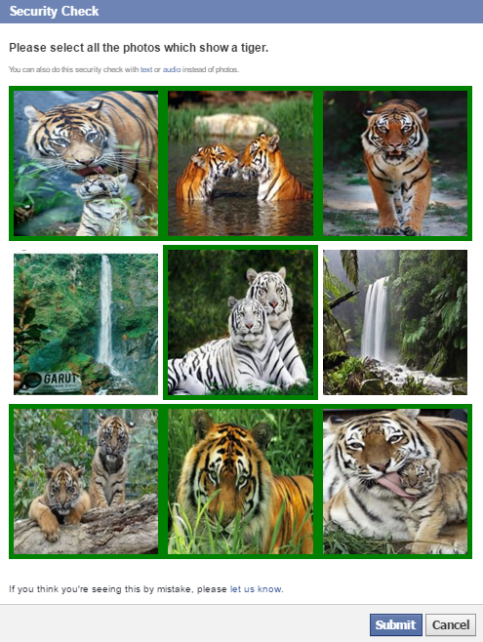

* *The Dashboard will be opened and from the left pane select “Settings”*

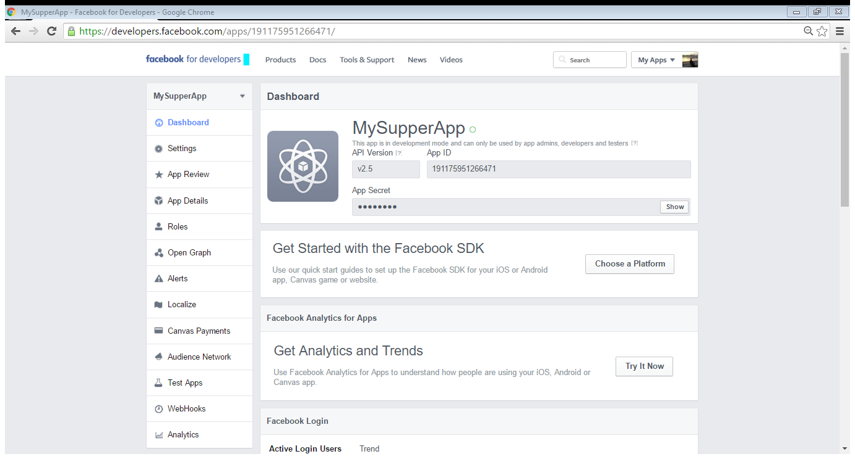

* *Go to “Advanced” Tab*

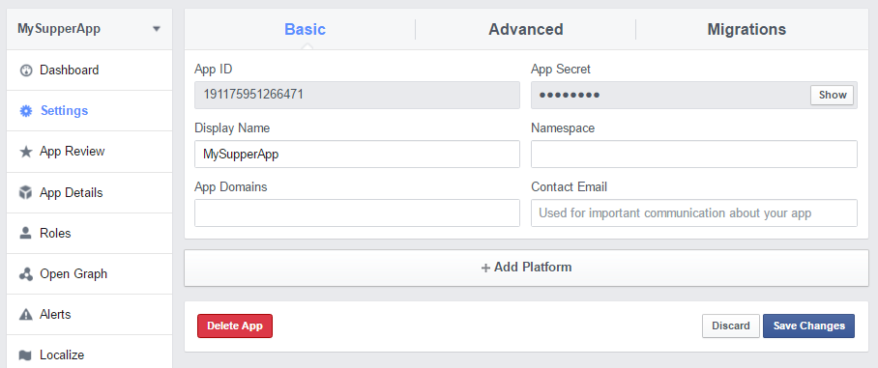

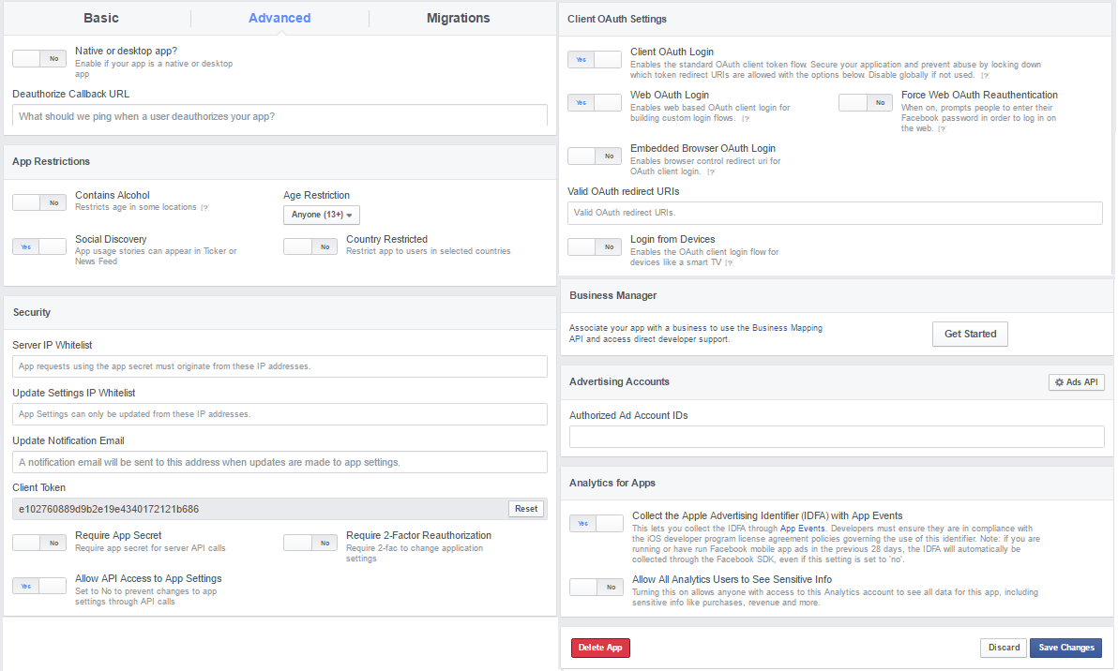

* *Under “Client OAuth Settings” tab, use the default settings > Enter the project URL followed by signin-facebook. Enter following in Valid OAuth redirect URLs:* [*http://localhost:65053/signin-facebook*](http://localhost:65053/signin-facebook) *> Click “Save Changes” button.*
* *Now go to Basic Tab > and click on “Show” button > Enter Password > click “Submit” button*

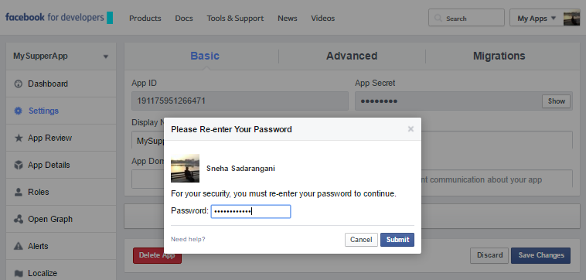

* *The App Id and App Secret will be visible:*

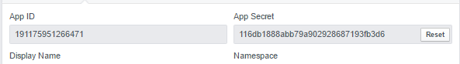

* *Enter below AppId and AppSecret details in Startup.Auth.cs as shown below:*

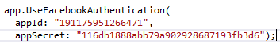

* *Logout from Facebook Account*
* *Now execute the code:*

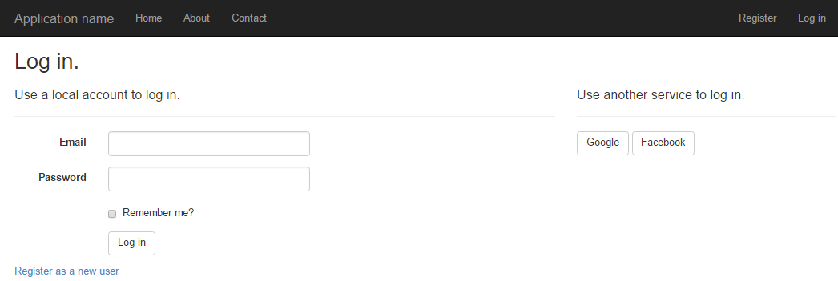

*Click on Facebook button*

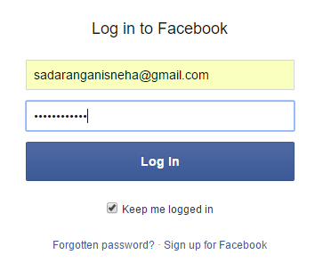

*Enter the facebook credentials > click on Log In button*

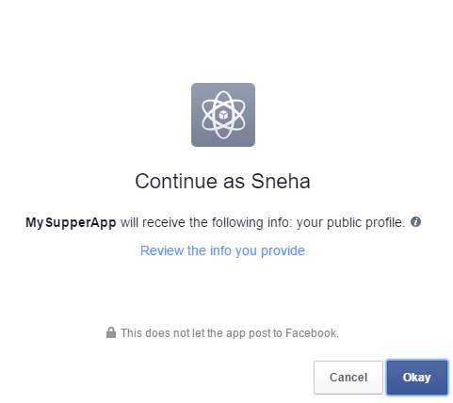

*Click OK button*

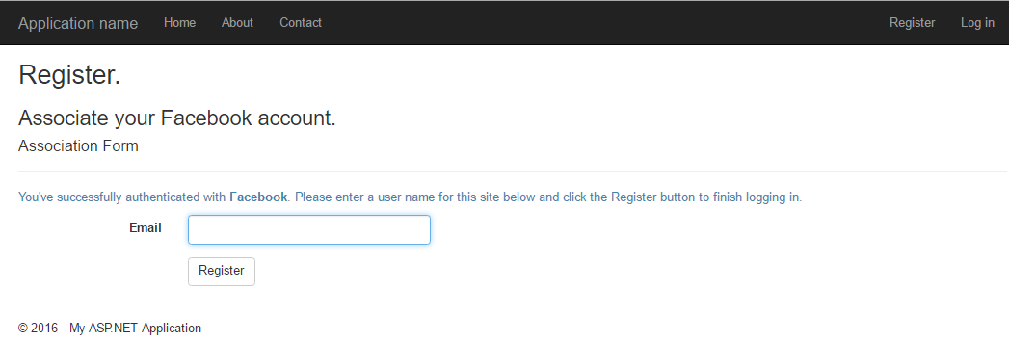

*Enter Email Id and click on Register button*

